**TASK:3**

**CREATING A MINIKUBE SERVICE TO HANDLE CONTAINERS**

**AIM:**

**The objective is to push a Docker image to Docker Hub and deploy it on Minikube to ensure that the application runs successfully in a Kubernetes environment.**

**This involves:**

**Building & Pushing Docker Image:**

* **Creating a Docker image of the application.**
* **Pushing the image to Docker Hub for accessibility.**

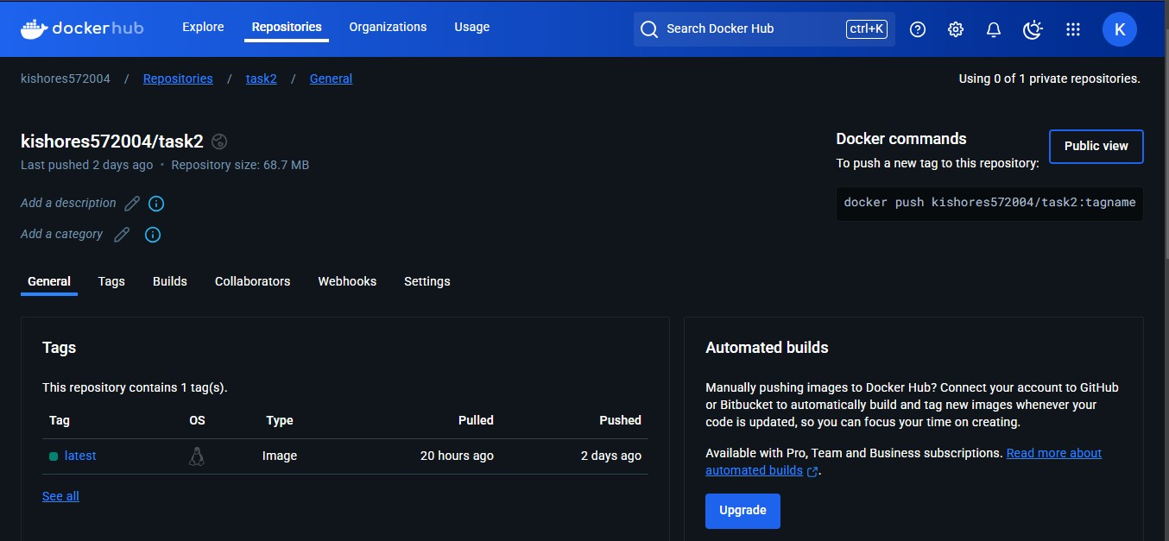

**Setting Up Minikube and Verifying Deployment:**

* **Starting a Minikube cluster locally.**
* **Configuring Minikube to pull images from Docker Hub.**
* **Checking if the pods are running.**
* **Accessing the application through Minikube service.**

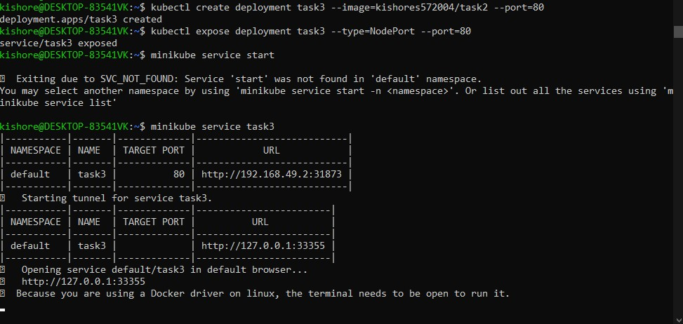

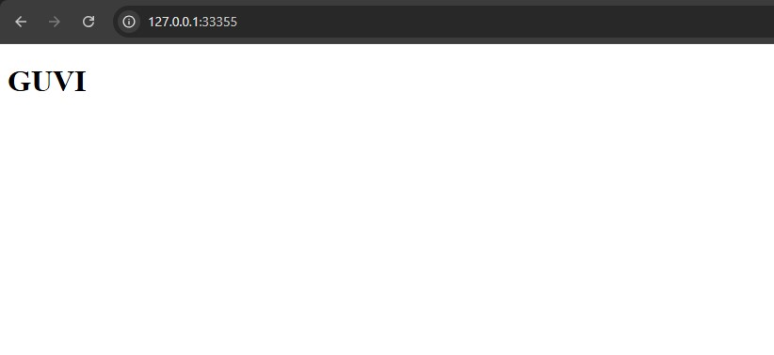

**Submitted by :**

KISHORE S

22ISR018